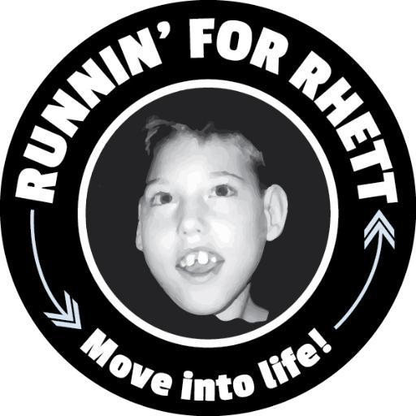
ALL ABOUT RHETT
Rhett Seevers was born on February 7, 1997. He went home from the hospital with his mom and dad, Randy and Beth Seevers, but soon the family noticed something was not right with Rhett. After many visits with doctors and lots of tests, the doctors told Beth and Randy that Rhett had cerebral palsy. The disease would affect his arms and his legs, so much that Rhett was not going to be able to crawl or walk.

Even though there were many challenges for Rhett, he still enjoyed life. Like most children, he loved to swing, take rides in a wagon and go for long walks in his stroller. Rhett also loved listening to music. He was sick a lot, especially during the wintertime, and often had to go to the hospital to be helped. When Rhett was 7 years old and very sick, he was taken to the hospital. Sadly, Rhett passed away at the hospital, surrounded by his family.

Rhett’s parents were very sad after they lost their little boy. A friend encouraged his mom to start running to help her deal with missing Rhett. When Beth found out that the Shamrock’n Half Marathon was going to be held on the date Rhett had passed away, she knew she HAD to run the race. She was going to do it for Rhett! Inspired by her son, Beth trained and finished the race. The next year she asked friends and family to run Shamrock’n with her. They all decided to wear baby blue running shirts to honor Rhett. More and more people joined the group, they ran more races, and then the group became so big that Runnin’ for Rhett, A Non-Profit Organization, was started in 2007. People were inspired by Rhett’s story and they wanted to encourage others, both adults and children, to get up and move- walk or run- because they could!

YOU are now a very important part of the Runnin’ for Rhett family. So are 4,000 other school children in the area that you will be running with on race day. You will all wear baby blue shirts, just like Rhett’s mom wears when she runs. Rhett’s parents hope that now that you know Rhett’s story, you can do what Rhett wasn’t able to do; run or walk. You can do it… You can MOVE INTO LIFE…YOU can RUN FOR RHETT!

