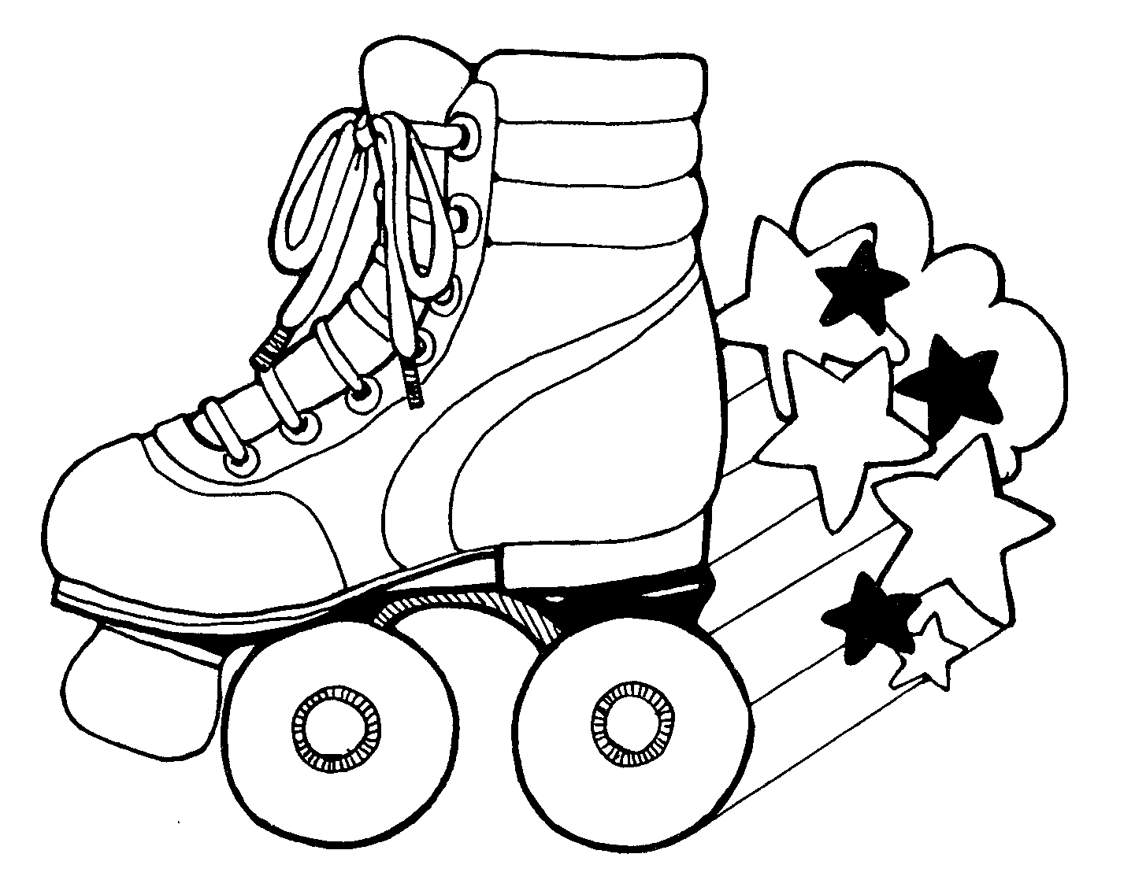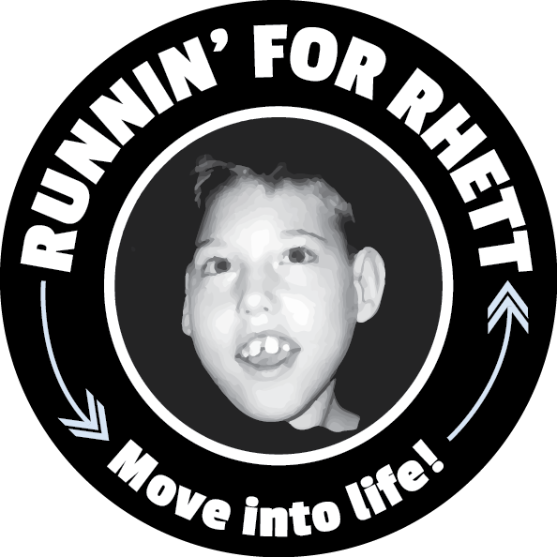

Join us for our Rollin’ for Rhett celebration!
Who: Youth Fitness Program participants and their families
What: Skating and celebrating completing the Run Because You Can 5K
Where: The Rink, 2900 Bradshaw Road, Sacramento, CA 95827
When: Monday, May 6th, 6-8 pm

- Free for all Youth Fitness Program participants and family members!!!
- $5.00 donation (tax deductible) would be appreciated, but is not necessary.
- Wear your R4R shirt and/or race medal to get a raffle ticket for prizes!!!
- The Rink concession stand will be open offering food items such as
  - hotdog for $3.50
  - a slice of pizza, pretzel with cheese, or nachos for $4.00
  - Family Special (a whole pizza and a pitcher of soda) for $22.00.

Join us for our Rollin’ for Rhett celebration!
Who: Youth Fitness Program participants and their families
What: Skating and celebrating completing the Run Because You Can 5K
Where: The Rink, 2900 Bradshaw Road, Sacramento, CA 95827
When: Monday, May 6th, 6-8 pm

- Free for all Youth Fitness Program participants and family members!!!
- $5.00 donation (tax deductible) would be appreciated, but is not necessary.
- Wear your R4R shirt and/or race medal to get a raffle ticket for prizes!!!
- The Rink concession stand will be open offering food items such as
  - hotdog for $3.50
  - a slice of pizza, pretzel with cheese, or nachos for $4.00
  - Family Special (a whole pizza and a pitcher of soda) for $22.00.

