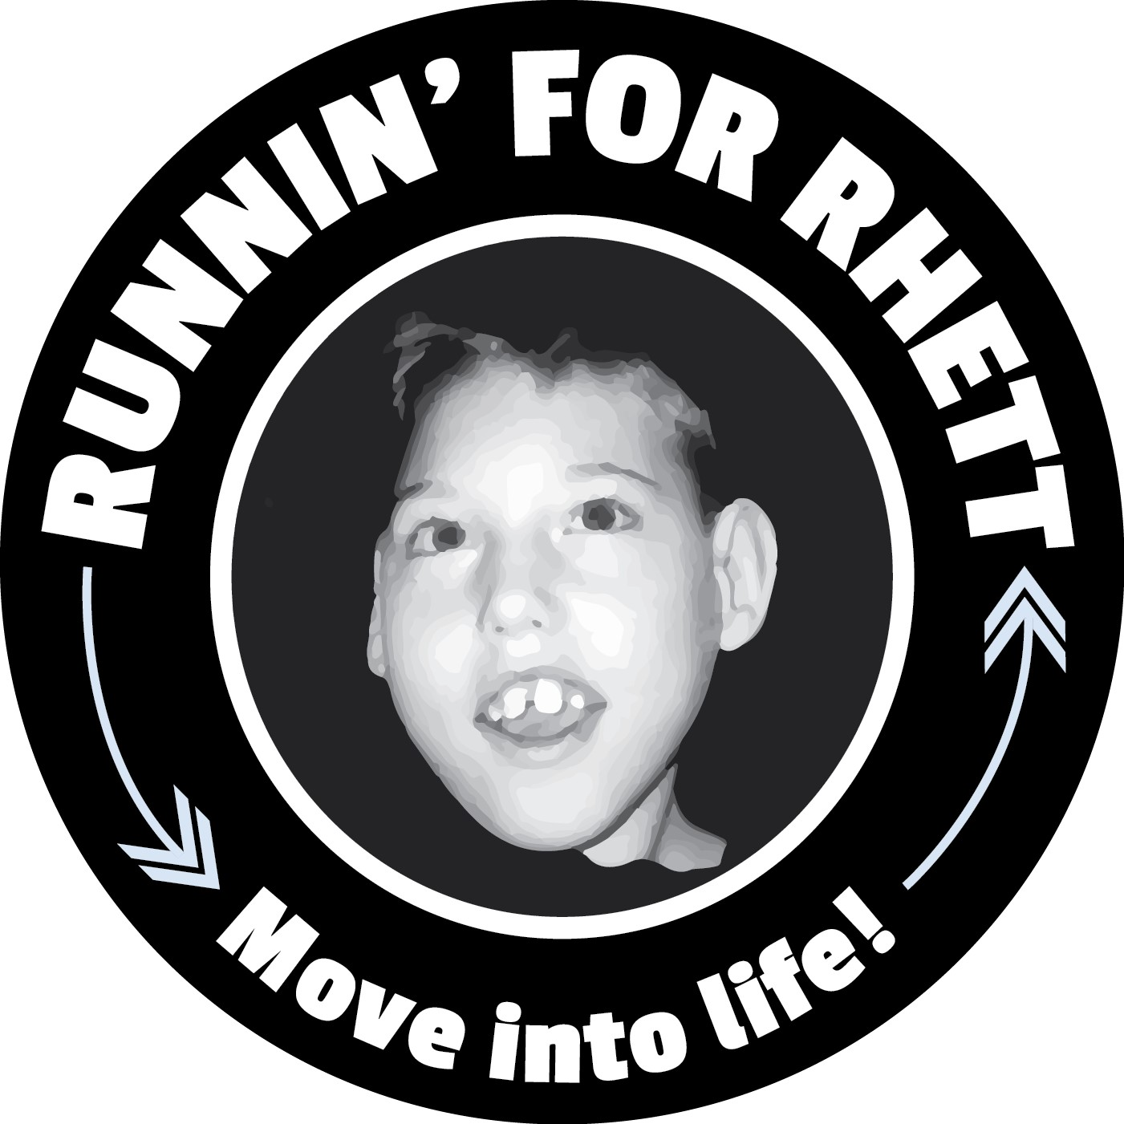
Spring 2025 Run Because You Can 5k
When: Sunday, April 27th 2025
Where: William Land Park –
3800 W Land Park Dr, Sacramento, CA 95822
Time: 1/4 Dash @ 8:30 & 5k @ 9:00

¼ Dash @ 8:30an
5k Race starts @ 9:00am

- If you filled out the permission slip for your child, they are already registered for the Run Because You Can 5K,

- Scan QR Code to Register:

$35.00 Registration $10 off Coupon: YFP10

Parents/Family: Register by April 18th to receive your bib and shirt from the school/coach you are affiliated with. After April 18th, pick up your bib at the registration tent on race day. (After the 18th, SHIRTS will be available first come, first serve) Upgrade to a Tech Tee for $10.00

