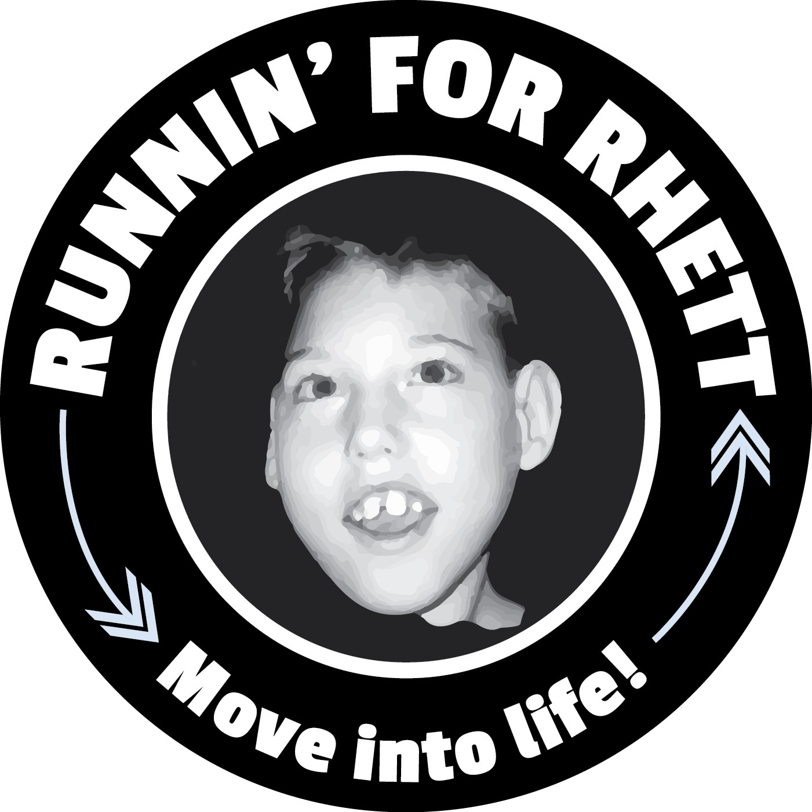
Fall 2025 MaraFUNrun 5k
When: Saturday, December 6th 2025
Where: William Land Park –
3800 W Land Park Dr, Sacramento, CA 95822
Time: 1/4 Dash @ 8:30 & 5k @ 9:00

¼ Dash @ 8:30an
5k Race starts @ 9:00am

- If you filled out the permission slip for your child, they are already registered for the MaraFUNrun 5K,

- Scan QR Code to Register: $25.00+fees- Parent Registration
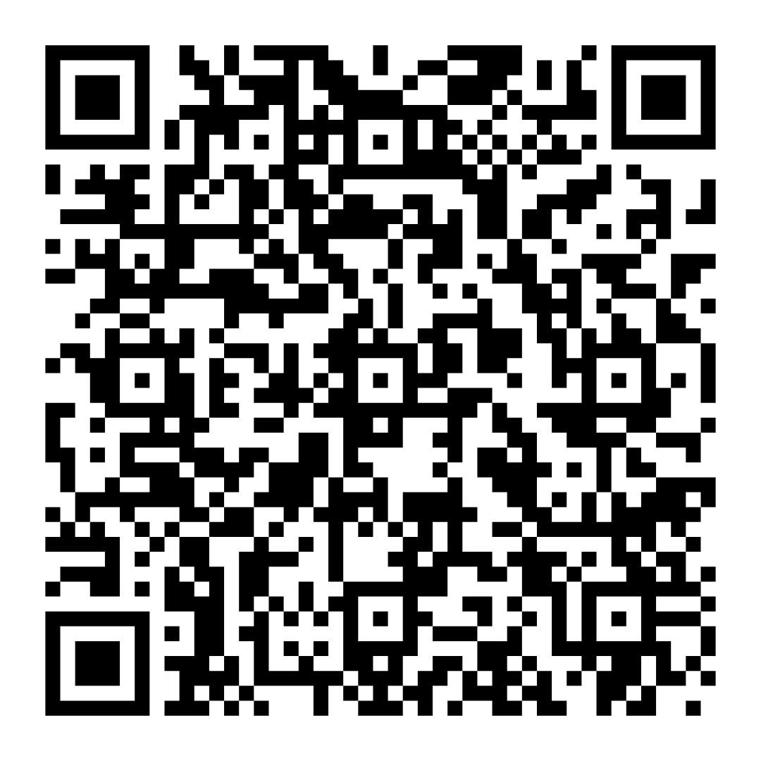
Parents/Family: Register by November 20th to receive your bib and shirt from the school/coach you are affiliated with. After November 20th, pick up your bib at the registration tent on race day. (After the November 20th, SHIRTS will be available first come, first serve) Upgrade to a Tech Tee for $10.00

