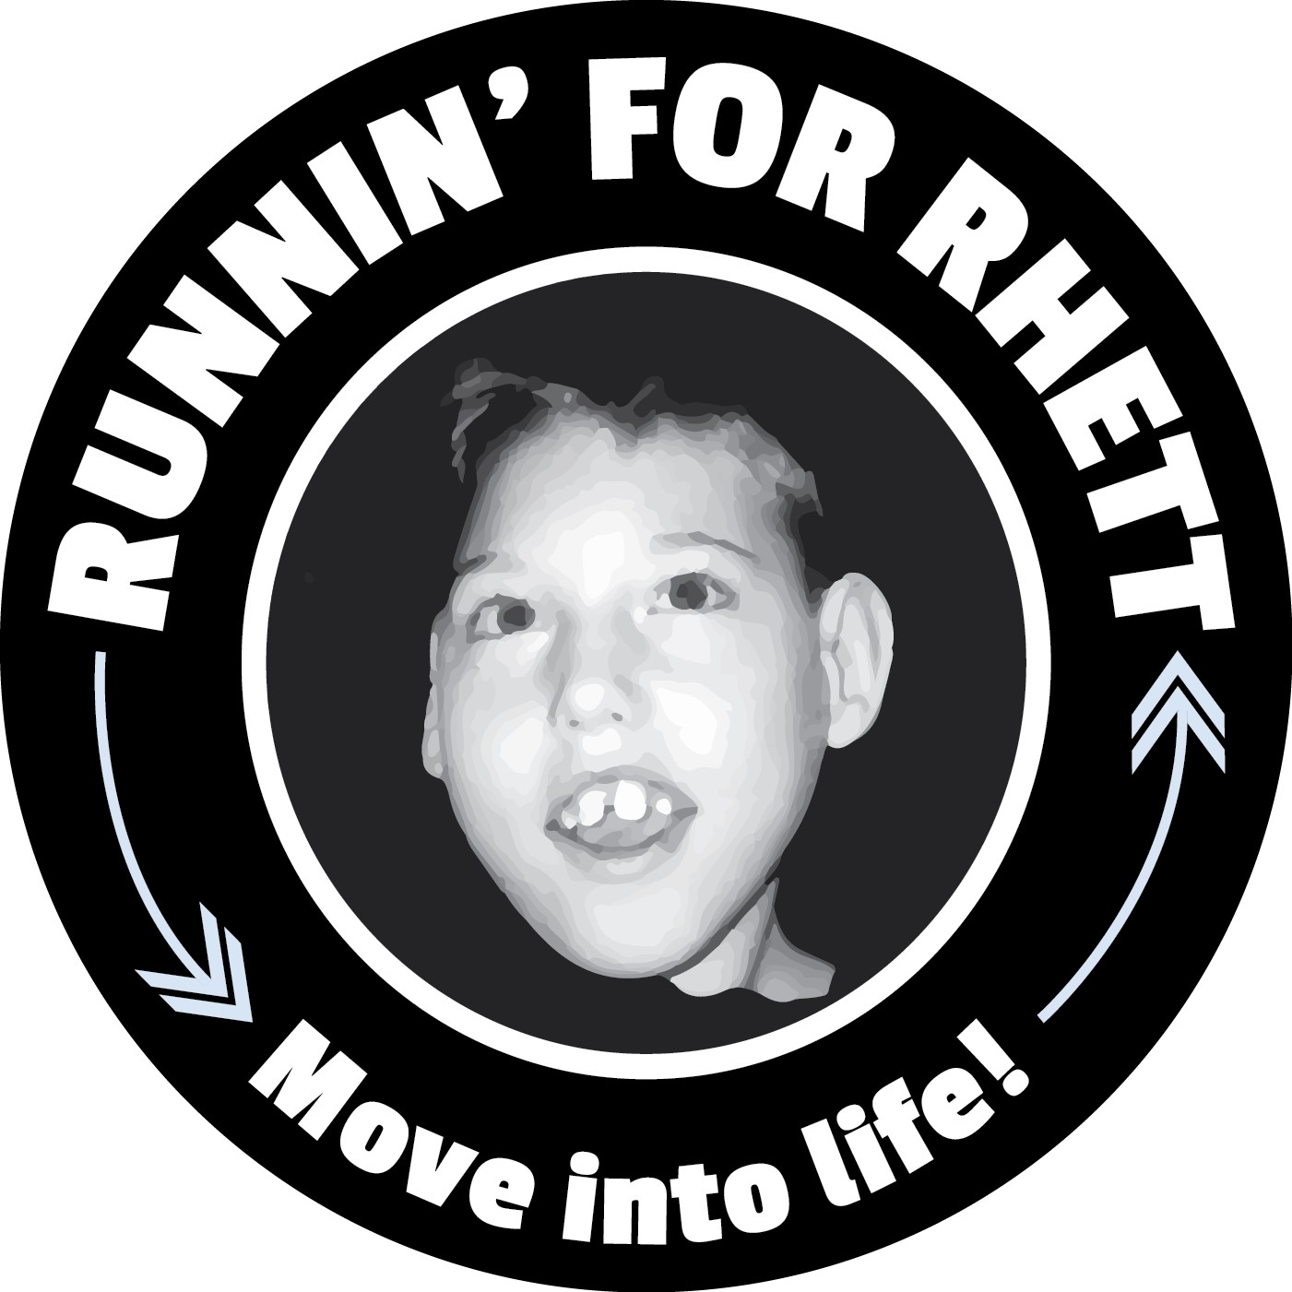
Spring 2026 Run Because You Can 5k
When: Sunday, April 26th 2026
Where: William Land Park –
3800 W Land Park Dr, Sacramento, CA 95822
Time: 1/4 Dash @ 8:30 & 5k @ 9:00

¼ Dash @ 8:30an
5k Race starts @ 9:00am

- If you filled out the permission slip for your child, they are already registered for the Run Because You Can 5K,

- Scan QR Code to Register:


$35.00 Registration w/$10.00 discount applied to registration

Parents/Family: Register by April 14th to receive your bib and shirt from the school/coach you are affiliated with. After April 14th, pick up your bib at the registration tent on race day. (After the 14^{h}, SHIRTS will be available first come, first serve) Upgrade to a Tech Tee for $10.00

